ASL Fusion Display LCD Not Starting Properly Issue HW Testing

|  |  |
| --- | --- |
| **Author** | **Date** |
| Trevor Parsh | 10/25/2021 |

Contents

Purpose 2

What is Known 2

Setup 2

Test Procedure 2

Test Results 3

Test 1: Reproducing the Issue 3

Test 2 3

Test 3 4

Test 4 4

Test 5: Reseat the LCD connector 4

Test 6: Remove Back Light 5

Current Assessment 7

# Purpose

Trying to figure out why the LCD does not display any screen on boot sometimes. This bout of testing is targeting hardware-based faults for the cause of failure.

# What is Known

It is known that “waiting for the board to warm up” results in the LCD working properly.

# Setup

Hooked up an oscilloscope to the 3.3VDC net and a benchtop power supply to B1 and B4. No other external connections are made to the board.

# Test Procedure

The test procedure is “reactive”. It’s a try this, if that doesn’t work, go back to the drawing board and try something else sort of deal. Generally, here’s what it looks like:

1. Reproduce the issue.
2. Reseat the LCD connector, see if the issue persists.
3. Digest the schematic.
4. Toy with different power up sequences and delays between them.
5. Think, change/remove parts on the board, repeat.

# Test Results

The issue is easily reproduced. The first issue was that +5VDC was being supplied as per what is shown in the schematic. However, the board has been modified to run strictly off +3.3VDC being supplied between B4 and B1 connection points. Luckily the board seems fine, but it is possible that a part has been damaged due to +5VDC being supplied to the board for many seconds.

## Test 1: Reproducing the Issue

Having the device powered down for 1 minute, then powering it up off of the power supply caused the LCD to show a back lit black screen. The oscilloscope capture is shown below.

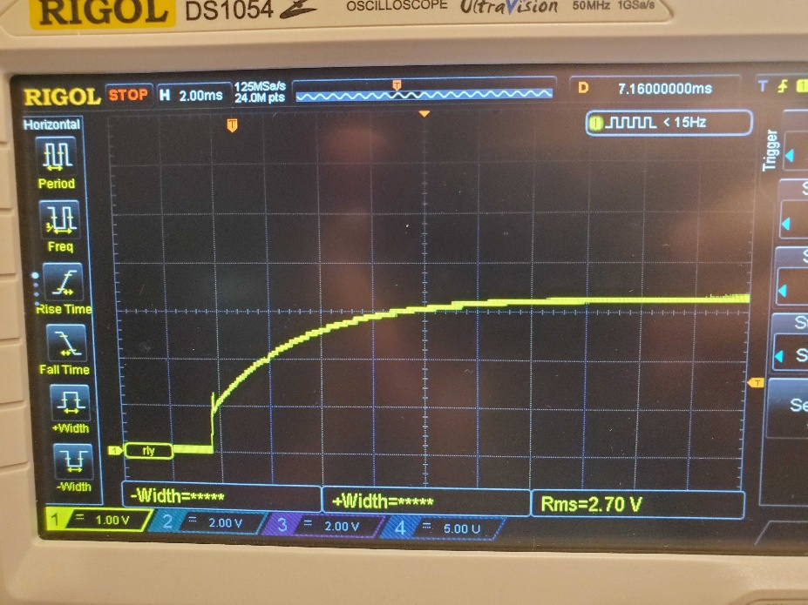

## Test 2

The issue went away after removing power for ~200 ms then reapplying power. This has been done by pressing the on/off button twice on the power supply. The oscilloscope capture is shown below.

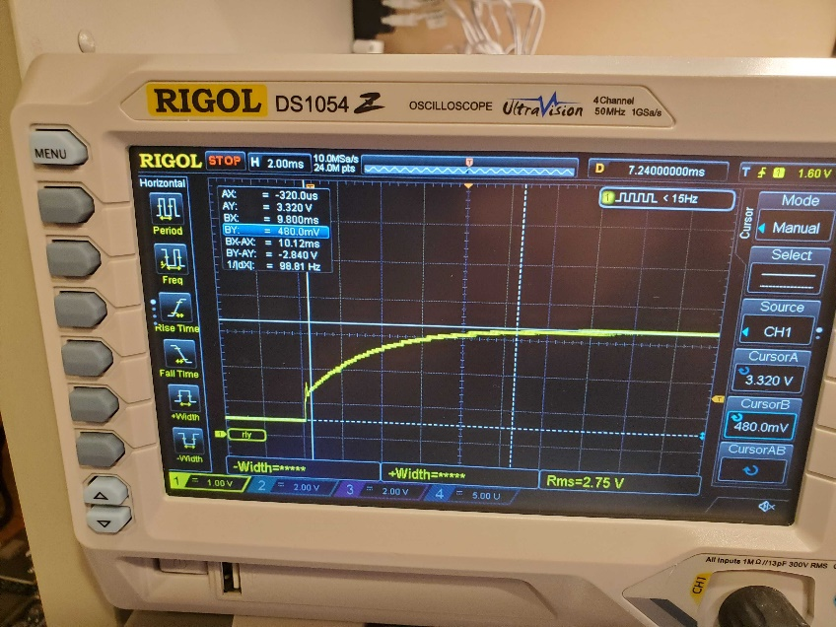

## Test 3

From the last test, the the V+ cable from the power supply was removed and plugged into the V- terminal for ~2 seconds to drain all energy from the board. Then, the V+ cable was plugged back into the V+ terminal (power supply remained on the whole time). The board behaves properly. The oscilloscope capture is shown below.

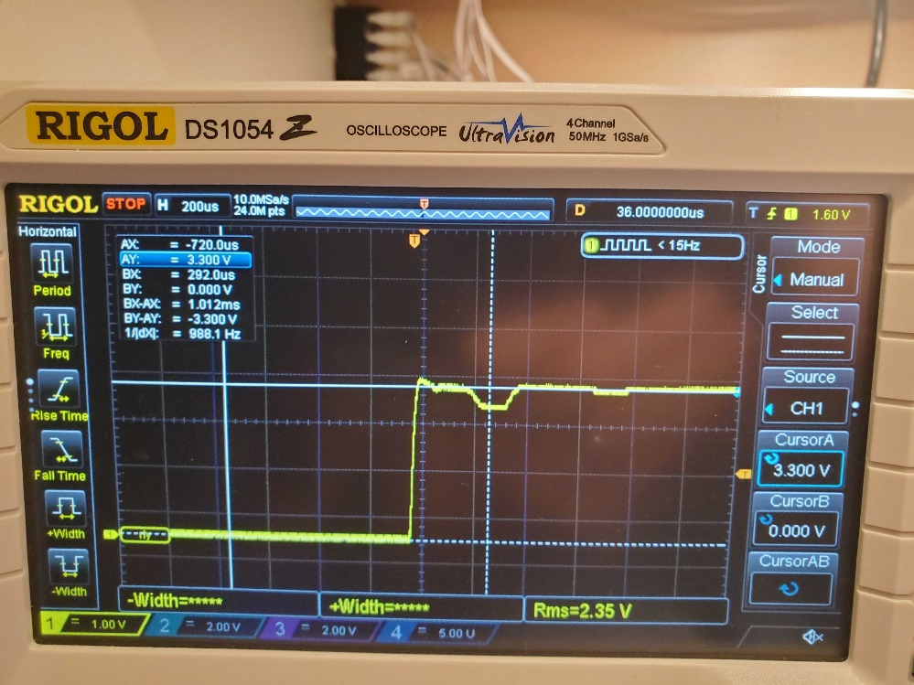

## Test 4

Next, it is desired to see a clean transition as is seen in the first two tests, but the voltage read by the oscilloscope reaching 0VDC before re-applying power. This is done by turning the power supply off for ~10 seconds, then turning it back on. No oscilloscope capture has been taken as the capture looks **exactly the same** as the capture from the first test.

## Test 5: Reseat the LCD connector

This was done before Test 2 and again after Test 4. The results are the same; the issue persists. Chop said that his device seems to be working properly after reseating the connector. He tried both a known good old display, then put the new display back in. Both worked properly.

## Test 6: Remove Back Light

The backlight was removed, which meant that an eternal light source needed to be put behind the display. The light in the picture below was used. It was held ~3” from any part of the DUT to ensure that all parts of the DUT had a negligible temperature change due to the light source. This light source is required as transmissive LCDs such as the one on the DUT require a light behind them or the screen is going to be viewed as black no matter what is programmed to be displayed.

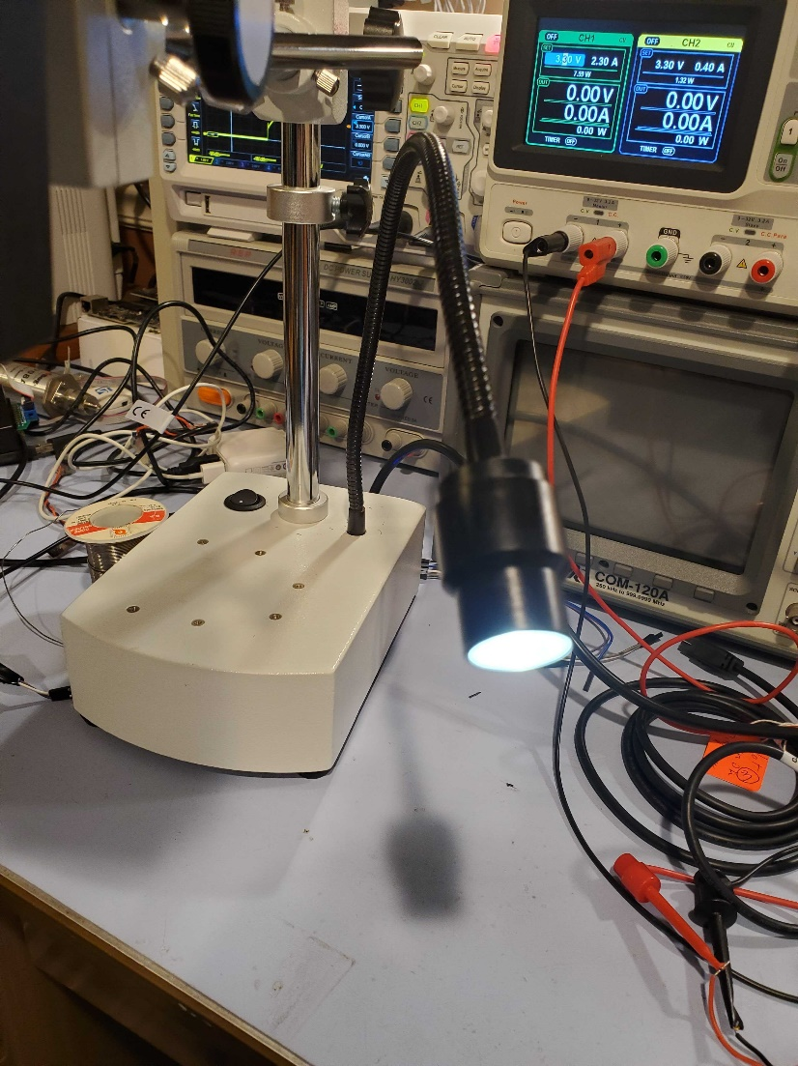

The current draw dropped to ~50-60 mA (power supply ammeter is limited to a resolution of 10’s of mAs). To see where the current draw is at, the display was removed entirely to have a reasonable idea. Of course, with the display attached, there is a possibility that other components draw more current. However, understanding the firmware well enough and the circuitry on the DUT’s PCB, it is highly unlikely that the current draw would change on the PCB itself with the absence of the LCD. The ammeter on the power supply again showed a current draw of 50-60 mA. This means that the current draw is in the 55-60 mA range, likely sitting right around 55 mA. Further analysis could be done, but it is likely not necessary. This current draw is quite likely being drawn almost entirely by the MCU. Given how isolated the MCU is from everything else in the test setup, it is only heating itself up. This means that the only problems that could exist would be in the MCU’s silicone or with the MCU’s solder joints. Upon inspection, the solder joints look good. It is highly unlikely that there is a silicone issue in the MCU.

# Current Assessment

Not sure what the issue(s) is(are) yet. Since the energy from the board is completely drained from the board before applying power and both the “success” and “failure” cases are easily reproducible, the issue is not related to power supply bring up on the board.

The most likely issue is that something is not active until it is heated up by the back light. Checking to see if the issue never resolves if the backlight is off should be tried next.

Highly doubt that the issue may be resolved with an increased temperature of any component on the board, using Test 6 as proof.